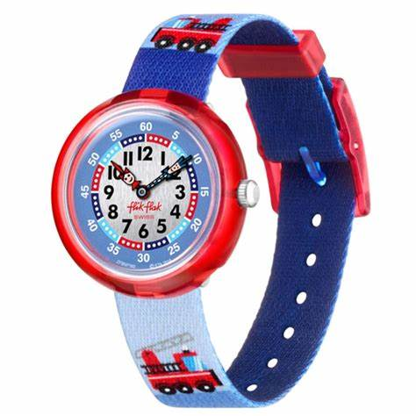**Description**: **Flik Flak** is a Swiss watch brand specializing in high-quality, fun, and educational timepieces for children. Established in 1987 as a part of the Swatch Group, Flik Flak watches are designed to help kids learn how to read the time with their unique and colorful designs. Each watch features an easy-to-read dial with clear hour and minute markers, often incorporating the Flik and Flak characters to make learning engaging.

Flik Flak watches are Swiss-made, ensuring durability and precision. They use shock-resistant materials and machine-washable fabric straps, making them perfect for active children. Many models are also water-resistant, allowing kids to wear them while playing in water. With a wide range of themes, from cartoons to sports and fantasy designs, Flik Flak offers fun and educational timepieces that appeal to children of all ages.